*. Jira. Задача "Обновление сигнатур Clamav" (https://jira.tcsbank.ru/browse/IN-1755)[Petrova Yulia].
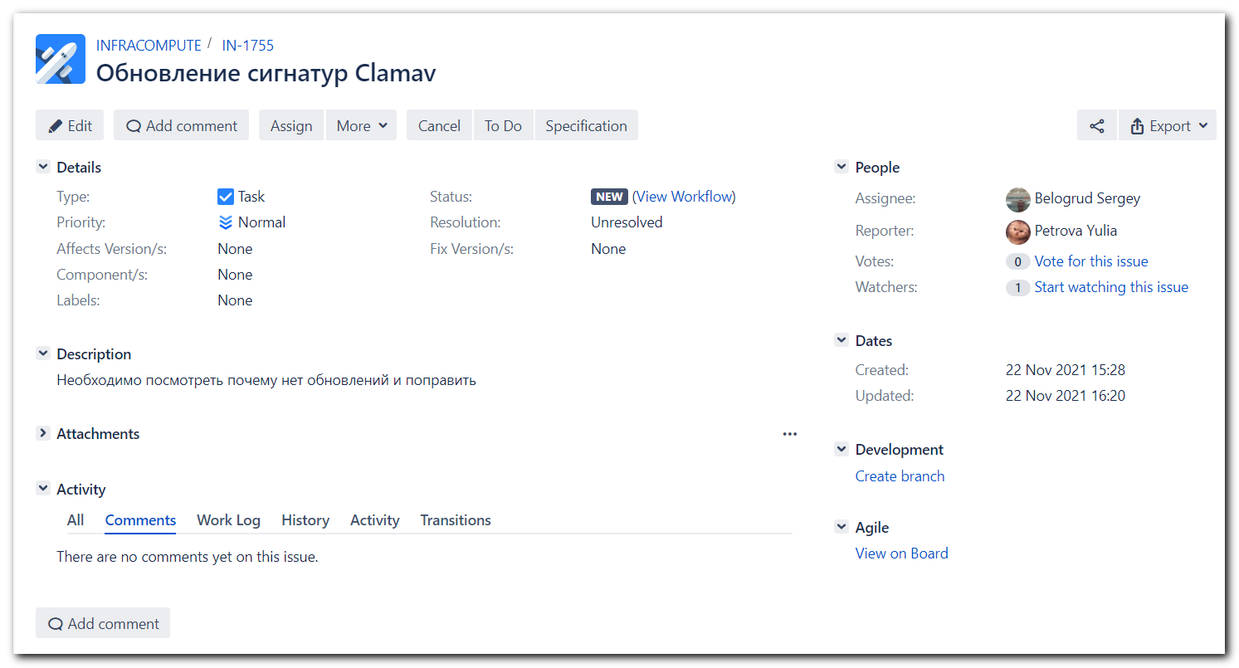

https://tinkoff.slack.com/archives/GHN18GB2M/p1637584238005100
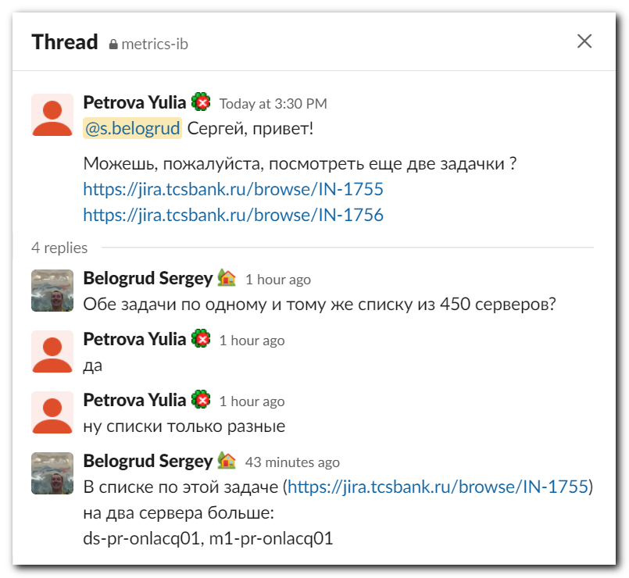

[support@nb2339]# export ANSIBLE_CONFIG=ansible.cfg ; logfile="$(date +%Y%m%d-%H%M).playbook.log.txt" ; ansible-playbook 20210708-1418.clamav_signatures.yml -i list_of_hosts --become --extra-vars "ansible_user=unix-ansible ansible_password=$(pass common/linux-unix-ansible) ansible_sudo_pass=$(pass common/linux-unix-ansible) ansible_ssh_common_args='-oStrictHostKeyChecking=no -oPubkeyAuthentication=no -oUserKnownHostsFile=/dev/null'" -f 10 | tee -a ./output/${logfile}

